Build Your Week Guide

So here I have included a template I pulled off of Google Images. I love the 24 hour and 7 day a week ones as they really give the best vision of what your life is like when you are done.
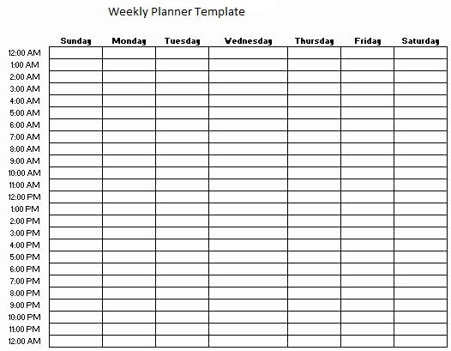
So grab some high lighters and a pencil! You will need them.
So where to start….hmmm. Well, as we discussed in Chapter 4, we will start with sleep.
Take your pencil and write “sleep” at the hour you would like to be in bed every night. Then write the word “sleep” in the hour you would like to get up. Do this under Sunday. Then draw an arrow from each word all the way across the page. Now take your favourite coloured highlighter and colour in all those squares.
Now the same for your meals. I do intermittent fasting so my first meal is usually at noon. I write lunch in at noon Sunday, then add the arrow all the way across and highlight it with a different colour. Then do the same for other meals. Now we have a foundation for sleeping and eating.
Now, if you put say 10 pm as your bed time, I would write down “down time” at 9 pm, arrow across the page and colour it.
Then we put in work. This can be the time you start your commute, the time you start to get ready for work, and of course, your time you are done work.
I trust by now you still have some white space. This is good. If you have none at this point, please feel free to email me at mike@theheromission.com
So the white that is left is your time. Remember that EVERYONE says they are too busy. But this is where you can see where you have a pretty standard schedule. You have at least an 8 hour gap on Saturday and Sunday.
Now think of once a week or twice a week things. For me, I pick a gap and put in grocery shopping, going to church every Sunday, the time I spend playing Dungeons and Dragons every week and when I sit with my wife and watch a movie.
Add these things and colour them.
Then figure in some time to work on your goals. Factor in when you could take a course, go to the gym, get outside. Now look. You should still have a bunch of free hours left. Those are yours.
I always am amazed at how much time I have left over even with 2 jobs. If you find yourself feeling burnt out or like there is not enough time, then you are either not accounting for the wasted time (tv watching, surfing the web, etc) or your body may be in fact burnt out. If this is the case, this schedule template has just helped you figure out where you can make changes! Maybe it is naps on Saturday and Sunday. Maybe it is having a stricter bedtime and wakeup schedule. Maybe it shows you where you could give up something to do something better with that time. I love helping people with this in my life coach practice. Please feel free to email me about it.

